For by the grace given me I say to every one of you: Do not think of yourself more highly than you ought, but rather think of yourself with sober judgment, in accordance with the faith God has distributed to each of you. **~Romans 12:3**

Do not be anxious about anything, but in every situation, by prayer and petition, with thanksgiving, present your requests to God.

**Philippians 4:6**

July 2024

Center United Methodist Church

PO Box 626

4th & Broadway,

Center CO 81125

Worship Services: 9 am

In person and Online (Zoom)

Church Phone: 719-754-2243

E-mail: umcofcenter@gmail.com

Financial E-mail:

CUMCfin@yahoo.com

Website: umcofcenter.com

Pastor

Rev. Amos Kariuki

Phone: (303) 621-6351

167 W. 4th

Center CO 81125

Email:akariukiumc@gmail.com

Pastor Hours

Monday: 9:00am – 4:30pm

Wednesday: 9:00am – 4:30pm

Friday: Day Off

Administrative Assistant

Alanna Garcia

(719) 850-1342

Volume 39 Issue 6

**Pastor Amos**

Greetings!

I attended the Annual Conference that took place in Casper WY June 20-23 and the following was the highlight:

* The conference celebrated recent General Conference results but mourned

departing churches.

* A sense of hope for the future and opportunity to redefine the United Methodist

Church prevails.

* Bishop Karen Oliveto is retiring; a new Bishop will be assigned in July.
* The conference acknowledged the church’s role in past wrongs and committed

to healing with Indigenous Tribes.

* The keynote speaker challenged the church to embrace its radical roots and fight

for social justice.

* Support programs for struggling small congregations were discussed
* The next conference will be held next June 11-14, 2025, at St. Andrew’s Church,

Highlands Ranch.

My new full-time appointment here at Center UMC starts this July. I am looking forward

with great anticipation to continuing serving with you all. Service time remains the

same...9:00 am.

After years of absence Vacation Bible school is coming back. It will be on July 15-18

from 8:30 am till 12 noon. It will be directed by Lori Sanchez. We can use some help

and I encourage you to attend meetings on Wednesdays at 2:00 pm to assist with

planning. We need snacks; you are invited to contribute. Feel free to contact Lori at

719-588-5752 to find out how you can volunteer. You may also reach out to Alanna, the

office manager, at 719-850-1342.

The VBS is part of the A Table for All projects we have undertaken this year. I’m so

excited about that because the coaching we have received from Ministry Incubator

Aqueelah Ligonde is bearing fruit. We will publicize the VBS through Facebook,

Instagram, Text Message, X etc.

A big summer concert is coming to Center UMC on Tuesday August 6 at 7:00 pm.

Crystal River, born, raised, and headquartered in Lubbock, TX, tours extensively to all

parts of the United States sharing their music, personal testimony and many

“family” experiences that so many people can relate to. Come and meet the Gonzalez

brothers Joel, Carlos and Hector and their nephew Tom and enjoy a fun moment of

Christian music and heartfelt worship! Center UMC will offer dinner.

There will not be a Church Council meeting in July. The next will be in August. Other

meetings will go on as scheduled.

On a different note, I would ask prayers for Kenya. In the last few days there have been

demonstrations led by Gen Zs protesting the finance bill that was going to raise taxes

immensely. The demonstrations begun as peaceful but on Tuesday June 25 when the

parliament approved the bill there were riots, people were killed and injured by the law

enforcement agencies and property were destroyed. Although the president conceded

and withdrew the bill it was too little too late.

Finally, I want to wish you all God’s blessings as you enjoy summer.

God bless you all!

170

**Rev. Amos Kariuki**

**Kids Hope USA**

*(Haskin Elementary)*

**Art Supplies:** paper (manila, construction, cardstock, notebooks), crayons, washable markers, pencils (colored & #2), scissors (child safe), glue sticks, yarn or string, child friendly magazines, stickers, stamps and stamp pads, rulers, watercolors, pipe cleaners.

**Games:** board games, chess, checkers, dice, dominoes, etc., child friendly card games (Spot it, Uno, Phase 10, Go Fish, Old Maid, basic playing cards)

**Outdoor Activities:** balls, jump ropes, sidewalk chalk

**Books:** for Kindergarten, 1st, and 2nd Grade.

**Rainbow’s End/ LaPuente**

Make clothing, household items, and furniture donations to Center’s Rainbows End. Make canned food donations to Center’s Rainbows end or LaPuente in Alamosa. Make monetary donation to LaPuente though the church or online at:

<https://lapuentehome.org/donate/>

**Anna’s Mission Inc.**

*(Ready to Go bags for domestic violence victims).*

Toothbrush, Toothpaste, Body soap, Shampoo/ conditioner, Body lotion, Deodorant, Comb/brush, Razors, Small box of tissues, Gift cards to Family dollar or Dollar General.

<https://annasmissioninc.com/>

**We appreciate all donations and prayers for Domestic Violence Survivors.**

Christian “Vocal” Band Crystal River from Lubbock, TX is coming to Center, CO!

A true love for music that was nurtured in a “close knit” family environment, along with a sincere desire to reach out to people with God’s message has made Crystal River an important instrument for God in today’s world. With Christian songs ranging from mellow contemporary to country and southern gospel as well as other styles, and with personal testimonies covering a wide variety of topics, this group has been on the road since August of 1980. With over 50 recordings to date, and with appearances on the TBN and Primetime Christian Television Networks, as well as a “daily” radio program that can be heard worldwide through Facebook and the internet, Crystal River has had the opportunity to reach many souls with the message of God’s love through song, music, and testimony. Born, raised, and still headquartered in Lubbock, TX, Crystal River tours extensively to all parts of the United States sharing their music, personal testimony and many of their “family” experiences that so many people relate to. Come and meet the Gonzalez brothers Joel, Carlos and Hector and their nephew Tom and enjoy a fun moment of Christian music and heartfelt worship!

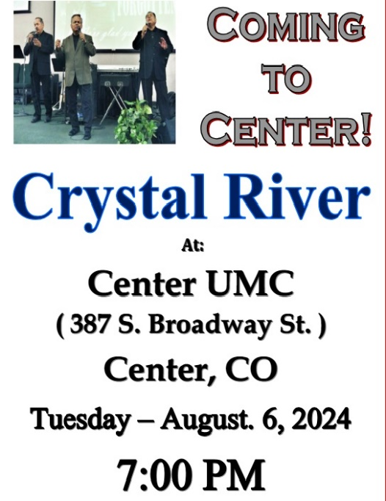

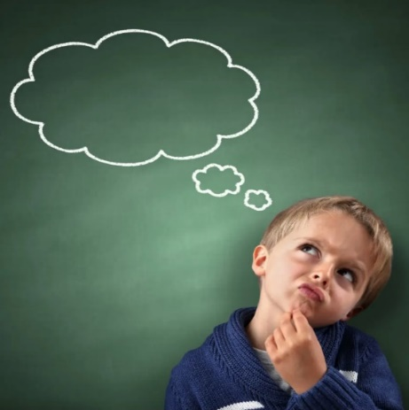

* **We will not be having 50+ this month but, will resume in August.**
* **Worship Committee will be meeting July 8th at 9:00am**
* **There will be no Church Board meeting this month.**
* **Our Chosen bible study is on Wednesdays at 6:00 pm at Janet’s house at 6pm. We are currently on Season 3**
* **A big summer concert is coming to Center UMC on Tuesday August 6 at 7:00 pm. Crystal River.**
* **Vacation Bible school is coming back. It will be on July 15-18 from 8:30 am till 12 noon.**

**Something to Think About…**

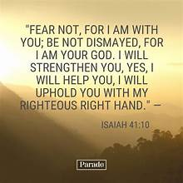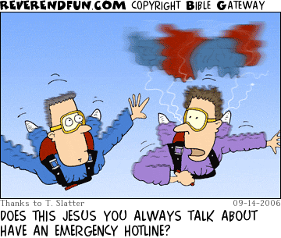

**Banana Macadamia Muffins**

**Ingredients**

* 3 cups all-purpose flour
* 2 cups sugar
* 2 teaspoons ground cinnamon
* 1 teaspoon baking soda
* 1 teaspoon salt
* 3 large eggs, room temperature
* 1 cup canola oil
* 3 medium ripe bananas, mashed
* 1 cup sweetened shredded coconut
* 1 can (8 ounces) crushed pineapple, drained
* 1 cup macadamia nuts, coarsely chopped
* 1 teaspoon vanilla extract

**Directions**

1. Preheat oven at 375°. In a large bowl, combine the first 5 ingredients. In another bowl, combine the eggs, oil and vanilla. Stir into dry ingredients until just moistened. Fold in the bananas, coconut and pineapple.
2. Fill greased or paper-lined muffin cups two-thirds full. Sprinkle with nuts. Bake for 18-20 minutes or until a toothpick comes out clean. Cool for 5 minutes before removing from pans to wire racks.

**https://www.tasteofhome.com/recipes/banana-macadamia-muffins/**

Recipe by: Amy Glander

**Kids Hope Report**

Kids Hope has been taking the month of June off. Now it is time to start thinking about getting ready to for a Fun, Exciting, and Challenging 2024-2025 school year.

To help support our Mentors and students we could use the following supplies:

Games:

Card games: Spot it, Uno, Phase 10, Go Fish, Old Maid.

Deck of playing cards, Dice, Dominoes, Candy Land Chutes and Ladders Guess Who, Connect Four, Jenga, Sorry, Puzzles

Legos

Art Supplies:

Watercolors, Yarn or String, Glue Sticks, Construction Paper

Card Stock, Notebook Paper, Washable Markers, Colored Pencils Magazines for collages (child-friendly)

Stickers, Erasers, Stamps and stamp pads (different colors)

Paint Brushes.

Thank you all for your continued support of our ministry to Haskin Elementary and their students.

God Bless

Vicki J Ratzlaff

Tasteofhome.com



